Spring is on the Way! Get Ready:
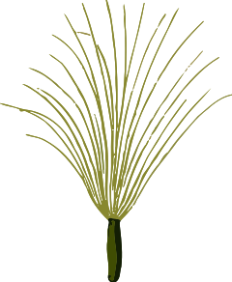
S
S
S
Stamford VT Seed Savers

Stamford VT Seed Savers 1st Annual
Seed Sharing Event

When: Saturday, Feb. 10th 2018 from 12 to 2 pm

Where: At the Stamford Fire Station
142 Stebbins Ln. (off Route 8)

Bring old seed varieties that you would like to share with the community or just bring your self, friends, and family. Come browse our collections of seeds.
Beginners and youth are welcome!

Drinks and homemade pastries from local bakers.

Free to the public!

